Zoe Boyle

Lab 4

1. 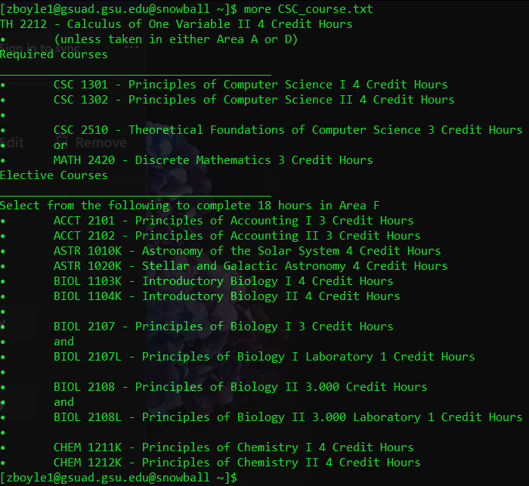
2. 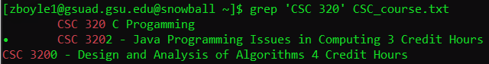
3. 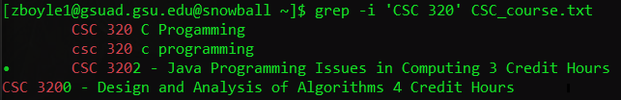
4. 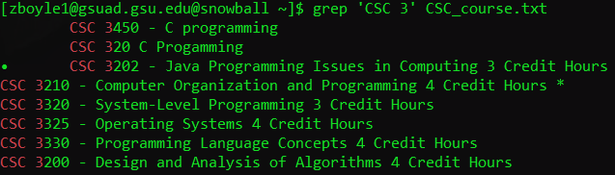

Finds lines containing ‘CSC 3’ and prints them

1. 

Looks for lines containing ‘CSC 3|CSC 1’, since there are none nothing was printed

1. 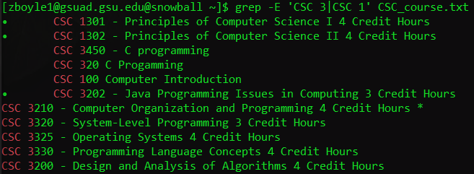

Finds lines containing either ‘CSC 3’ or ‘CSC 1’ and prints them

1. 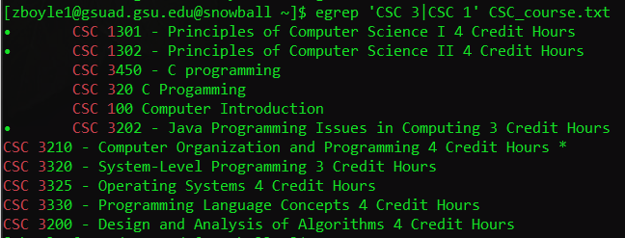

Finds lines containing either ‘CSC 3’ or ‘CSC 1’ and prints them

1. 

Finds and prints lines containing ‘3.000 Credit Hours’

1. 

Looks for a line with only 3.000 Credit Hours, there is none so nothing is printed

1. 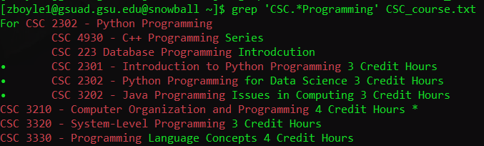

Finds and prints lines with ‘CSC’ and ‘Programming’ with any character zero or more times between them

1. 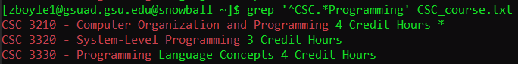

Finds and prints lines with ‘CSC’ and ‘Programming’ with any character zero or more times between them at the beginning

1. 

No result since it treats {} as character literals

1. 

Finds and prints lines containing ‘CSC’ and all characters except 3 zero or more times then by 3 two times and ending in any character except three zero or more times

It prints only the lines containing the exact pattern

1. 

Finds and prints lines containing ‘CSC’ and any character any number of times, followed by ‘C++’

1. 

Finds and prints lines containing ‘CSC’ and any character any number of times, followed by ‘C++’

1. Causes an error because the two greedy characters next to each other